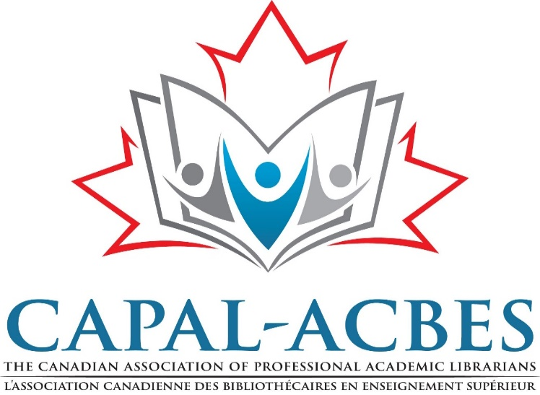

CAPAL-ACBES Statement on Academic Libraries and COVID-19

CAPAL-ACBES recognizes the importance of libraries in times of crisis. This statement addresses our concerns regarding library employees required to continue public service in the wake of calls for social distancing from all levels of government and administration. On March 11, the World Health Organization (WHO) assessed COVID-19 as a pandemic. Since that date, we have been closely monitoring rapidly evolving COVID-19 developments both in Canada and around the world.

In a national press conference on Sunday, March 15, 2020, Canada’s Chief Medical Officer of Health, Dr. Theresa Tam, stated that there are a “rapidly increasing” number of cases in the country, particularly in Ontario, B.C. and Alberta. She also now famously stated that, “Our window to flatten the curve of the epidemic is narrow. […] We all need to act now. COVID-19 is a serious public health threat.”

Since then, many provincial, territorial, and municipal bodies have issued advisories recommending closures, social distancing, and alternate work arrangements.Though local situations vary across the country, care and attention to the public health of our campus communities should take precedence over academic pursuits. MIT Libraries Director Chris Bourg wrote in her blog post entitled, Close the Library, “I encourage library directors to insist that our institutions not use the presence of libraries as a reason to hold all students accountable to the same standard of performance and participation. The inequities in higher education and in society will be on full display for the duration of this thing, and my personal and professional opinion (as a library director and a sociologist) is that using libraries to mask those inequities is bad for individuals, institutions, and society." While there is no perfect response, transparent communication is crucial as we make our best efforts to prioritize health and safety moving forward.

Many institutions have now moved to online course provision, and libraries and librarians are and remain an essential part of the online solution. CAPAL-ABCES wishes to emphasize that libraries were some of the earliest adopters of computer technology and have been collaboratively sharing bibliographic data since the 1960s. Librarians and library workers have extensive expertise in online environments, including systems development and design, preservation and access, user experience, and online instruction. Librarians and library workers regularly work with students and faculty via email and chat services.
A March 12, 2020 statement from the Canadian Association of University Teachers (CAUT) reminds us that academic institutions, “have a legal obligation to protect the health and safety of staff and students. Employees also have a right to refuse to work in conditions they reasonably believe are unsafe….In such cases, there should be no loss of pay or seniority during the period of self-isolation.” The health of our communities throughout this crisis will in part be reflected in and determined by the health of our libraries. CAPAL-ACBES urges university library administrators at post-secondary institutions across the country to support flexible work environments for all staff, namely the ability to work from home, to allow for social distancing and the protection and safety of employees and members.

Signed by the CAPAL Board of Directors
March 16, 2020

